Proven to lower NOTHING: Scientists reveal ‘LITTLE evidence’ probiotics improve health

SHOPPERS could be wasting their time and money on yoghurts, drinks and pills which could make their gut healthier.

By [OLIVIA LERCHE](http://www.express.co.uk/search/Olivia+Lerche?s=Olivia+Lerche&b=1)

PUBLISHED: 12:22, Tue, May 10, 2016 | UPDATED: 13:50, Tue, May 10, 2016

OVOLABS_4 END

|  |  |  |  |  |  |  |  |  |  |  |  |  |  |  |  |  |  |  |  |  |
| --- | --- | --- | --- | --- | --- | --- | --- | --- | --- | --- | --- | --- | --- | --- | --- | --- | --- | --- | --- | --- |
| |  | | --- | |  |  |  | | --- | |  |  |  | | --- | |  |  |  | | --- | |  |  |  | | --- | |  |  |  | | --- | |  |  |  | | --- | |  |  |  | | --- | |  |  |  | | --- | |  |  |  | | --- | |  |  |  | | --- | |  |  |  | | --- | |  |  |  |  |  |  | | --- | --- | --- | --- | | |  | | --- | |  |  |  | | --- | |  |  |  | | --- | |  |   **4** |  |  |  |  |  | | --- | --- | --- | --- | | |  |  |  | | --- | --- | --- | |  |  |  | | |

OVOLABS_5 START

C-ON-TEXT_CONTENT_START content

MAINIMAGE

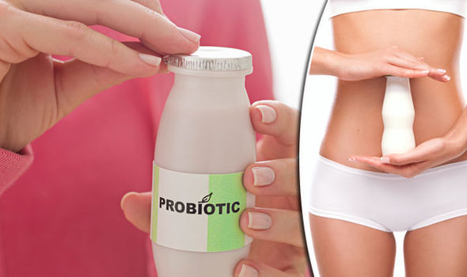

GETTY

Probiotics may not benefit healthy individuals, scientists have found

ENDMAINIMAGE

Probiotics are live ‘good’ bacteria and yeasts said to have various health benefits and are usually added to food or taken as supplements.

Many claim the products boost the immune system, reduce stress and improve sleep.

It is also claimed probiotics help restore the natural balance of bacteria in the gut including the stomach and intestines when it has been disrupted by an illness or treatment.

The gut is home to trillions of bacteria and it has long been established that whatever we eat affects these.

This colony consists of ‘good’ bacteria which have anti-inflammatory properties and ‘[bad](http://www.express.co.uk/life-style/health/623994/bad-bacteria-encourages-weight-gain)’ ones that promote inflammation.

Yet a new Danish study found there was little evidence to support many health claims made for them in otherwise healthy people.

RELATED ARTICLES

* [](http://express.co.uk/celebrity-news/403412/It-tastes-like-probiotic-drinks-Myleene-Klass-friends-and-family-drank-her-breast-milk)
* ['It tastes like probiotic drinks' Myleene Klass' friends and...](http://express.co.uk/celebrity-news/403412/It-tastes-like-probiotic-drinks-Myleene-Klass-friends-and-family-drank-her-breast-milk)
* [](http://express.co.uk/life-style/health/495603/keep-body-s-army-good-bacteria-strong-gut)
* [Feeling gut! The natural medicine kit... in your tum](http://express.co.uk/life-style/health/495603/keep-body-s-army-good-bacteria-strong-gut)

Professor Oluf Pedersen, author of the study, said: "While there is some evidence from previous reviews that probiotic interventions may benefit those with disease-associated imbalances of the gut microbiota, there is little evidence of an effect in healthy individuals.”

Researchers at the Novo Nordisk Foundation Centre for Basic Metabolic Research at the University of Copenhagen investigated the effect of the probiotic products on the gut flora of healthy adults by testing stool samples.

They looked the number of species present, the evenness or distribution of species within the populations and whether participants who took probiotics had different changes in bacteria living in their gut than those who did not.

PhD student and junior author Nadja Buus Kristensen said: "According to our systematic review, no convincing evidence exists for consistent effects of examined probiotics on faecal microbiota composition in healthy adults, despite probiotic products being consumed to a large extent by the general population.

"A systematic review of experimental evidence allows us to pull together evidence and look at the relationship between probiotic products and the composition of the faecal microbiota in healthy people using explicit, systematic methods, ensuring the highest level of evidence."

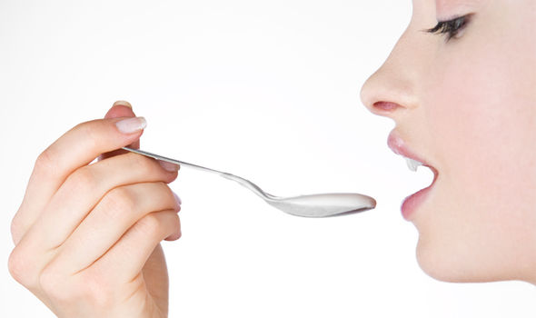

GETTY

Thousands of research articles have been published on probiotics

The study analysed seven original trials of healthy adults aged 19 to 88 and varied in size from 21 to 81 who took them either in biscuits, milk-based drinks, sachets, or capsules over three to six weeks.

Only one observed significantly greater changes in the bacterial species composition of the faecal microbiota in individuals who consumed probiotics compared to those who did not.

Previous studies had suggested common disorders like obesity, diabetes, or bowel cancer unbalances the faecal microbiota.

While their effectiveness in metabolic and gastrointestinal disorders can be measured for example against body mass index, insulin resistance or the severity of gastrointestinal symptoms, measuring the effect of probiotics in healthy individuals was more difficult.

Yet the study noted because of the small number of participants, the effect on individuals, differing strains and diet may have masked the true impact of probiotic intake.

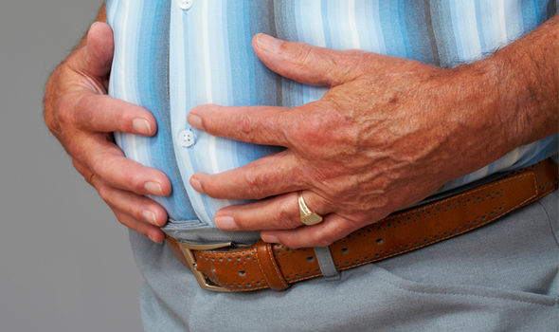

GETTY

Many people buy probiotic products

Celebrities master growing old gracefully

Thu, May 30, 2013

While many celebrities end up resembling caricatures of themselves after resorting to botox or extreme dieting to maintain their youthful looks, these few seem to have cracked how to age with grace and dignity.

|  |  |  |  |  |  |  |  |  |  |  |  |  |
| --- | --- | --- | --- | --- | --- | --- | --- | --- | --- | --- | --- | --- |
| |  |  |  | | --- | --- | --- | |  |  |  | |  |  |  | |  |  |  | |  |  |  | |

**PLAY SLIDESHOW**

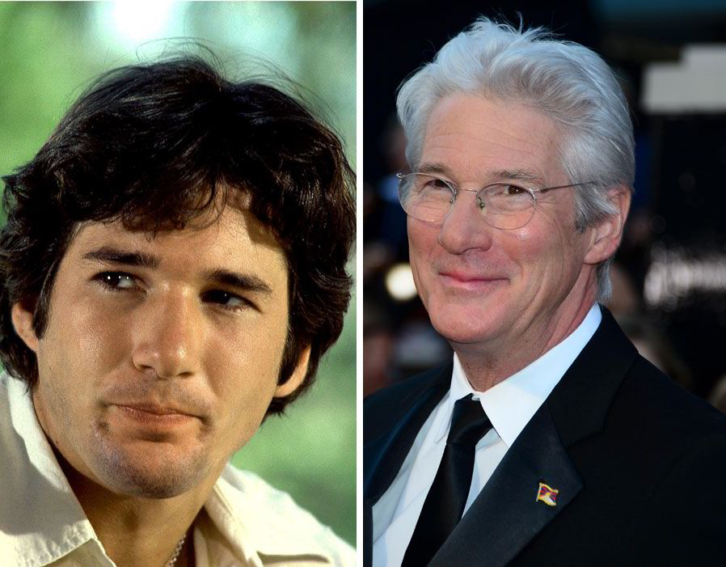

1 of 6

Richard Gere, 63, might have gone grey but still cuts a dashing figure (Pic: Express Picture Library)

* [ <img class="lazy-fallback" src="http://cdn.images.express.co.uk/img/dynamic/galleries/64x64/35395.jpg" alt="Richard Gere, 63, might have gone grey but still cuts a dashing figure (Pic: Express Picture Library)" title="Richard Gere, 63, might have gone grey but still cuts a dashing figure (Pic: Express Picture Library)" width="64" height="64" />](http://www.express.co.uk/pictures/galleries/1740/Celebrities-master-growing-old-gracefully/35395)
* [ <img class="lazy-fallback" src="http://cdn.images.express.co.uk/img/dynamic/galleries/64x64/35394.jpg" alt="Meryl Streep still looks fabulous at 63 (Pic: Express Picture Library)" title="Meryl Streep still looks fabulous at 63 (Pic: Express Picture Library)" width="64" height="64" />](http://www.express.co.uk/pictures/galleries/1740/Celebrities-master-growing-old-gracefully/35394)
* [ <img class="lazy-fallback" src="http://cdn.images.express.co.uk/img/dynamic/galleries/64x64/35393.jpg" alt="Sir Roger Moore, 85, still makes for a distinguished Bond (Pic: Wenn and Express Picture Library)" title="Sir Roger Moore, 85, still makes for a distinguished Bond (Pic: Wenn and Express Picture Library)" width="64" height="64" />](http://www.express.co.uk/pictures/galleries/1740/Celebrities-master-growing-old-gracefully/35393)
* [ <img class="lazy-fallback" src="http://cdn.images.express.co.uk/img/dynamic/galleries/64x64/35392.jpg" alt="Curvy Helen Mirren looks glamorous and classy at 63. (Pic: Express Picture Library)" title="Curvy Helen Mirren looks glamorous and classy at 63. (Pic: Express Picture Library)" width="64" height="64" />](http://www.express.co.uk/pictures/galleries/1740/Celebrities-master-growing-old-gracefully/35392)
* [ <img class="lazy-fallback" src="http://cdn.images.express.co.uk/img/dynamic/galleries/64x64/35391.jpg" alt="George Clooney is a silver fox at 52 (Pic: Express Picture Library)" title="George Clooney is a silver fox at 52 (Pic: Express Picture Library)" width="64" height="64" />](http://www.express.co.uk/pictures/galleries/1740/Celebrities-master-growing-old-gracefully/35391)
* [ <img class="lazy-fallback" src="http://cdn.images.express.co.uk/img/dynamic/galleries/64x64/35390.jpg" alt="Jane Fonda, 75, still has her youthful looks to smile about (Pic: Express Picture Library)" title="Jane Fonda, 75, still has her youthful looks to smile about (Pic: Express Picture Library)" width="64" height="64" />](http://www.express.co.uk/pictures/galleries/1740/Celebrities-master-growing-old-gracefully/35390)

Oluf Pedersen added: “To explore the potential of probiotics to contribute to disease prevention in healthy people there is a major need for much larger, carefully designed and carefully conducted clinical trials.

"These should include ideal composition and dosage of known and newly developed probiotics combined with specified dietary advice, optimal trial duration and relevant monitoring of host health status."

The study was published in the journal Genome Medicine.

Dr Linda Thomas, director of science for Yakult UK Limited, which makes probiotic drinks, said: “Academics and medics around the world acknowledge the benefits of probiotics for both short and long term health maintenance.

“Probiotics achieve such health effects via many different mechanisms of activity and not just by modulation of the gut microbiota.



GETTY

The journal was published in the journal Genome medicine

“However, it should be noted that the gut microbiota can be upset by many environmental and lifestyle factors over the course of a lifetime (e.g. poor diet, medication, old age, etc.), and these reduce its ability to help maintain health. Probiotics can help the gut microbiota to stay resilient to such disruption.

“Probiotic effects are also considered strain-specific, which can cause problems in interpreting results of meta-analyses.

“Trials investigating probiotics have reported a broad spectrum of positive effects for healthy people or those with sub-optimal health.”

Professor Glenn Gibson from the University of Reading said: “Probiotics are species of microorganisms.

“I am not surprised by observations that they do not markedly affect overall faecal microbial composition - given that many hundreds of other species already exist therein. It is a bit like adding hay to a haystack and expecting the new addition to be suddenly dominant.